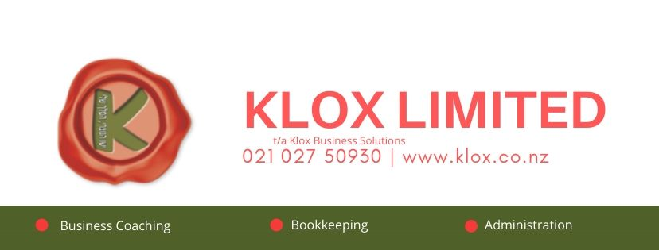

Annual Client Reflection Questionnaire

1. What are you most proud of from the previous year?

2. What was the worst thing or biggest learning?

3. What is the most valuable thing you learned about yourself?

4. Who were the most influential and supportive people for you?

5. What three things from the year are you most grateful for?

6. What do you wish you'd done more of?

7. What do you wish you'd done less of?

8. What three words sum up the year for you?

9. What skills could you better utilise this year?

10. What areas should you stretch this year?

11. What will success look like to you this year?

